DATA FILE

When accessing files through C, the first necessity is to have a way to access the files. For C File I/O that needs to be used is a FILE pointer, which will let the program keep track of the file being accessed. (Just as the memory address of the file or the location of the file).
For example:
FILE *fp;
Where, FILE (uppercase letters required) is a special structure that establishes the buffer area, and ‘fp’ is a pointer variable that indicates the beginning of the buffer area. It is defined within a system include file, stdio.h. The pointer fp is often referred to as a stream pointer, or simply a stream.

To open a file we need to use the fopen function, which returns a FILE pointer. Once a file is opened, we can use the FILE pointer to let the compiler perform input and output functions on the file.

FILE *fopen(const char *filename, const char *mode);
where, filename is a string that represents the name of the data file.

The modes are as follows:
r - open for reading
w - open for writing (file need not exist)
a - open for appending (file need not exist)
r+ - open for reading and writing, start at beginning
w+ - open for reading and writing (overwrite file)
a+ - open for reading and writing (append if file exists)

Note that it's possible for fopen to fail even if the program is perfectly correct: it might try to open a file specified by the user, and that file might not exist (or it might be write-protected). In those cases, fopen will return 0, the NULL pointer.
Here's a simple example of using fopen:
FILE *fp;
fp = fopen(“file.txt”.”r”);

This code will open file.txt for reading in text mode. To open a file in a binary mode we must add ‘b’ to the end of the mode string; for example, "rb" (for the reading and writing modes, we can add the b either after the plus sign - "r+b" - or before - "rb+")
To close a function fclose can use the function
fclose(fp);
fclose returns zero if the file is closed successfully.

remove() is used to rename a file and rename() is used to rename an existing file.

int remove(filename)
int rename(old filename, new filename)

Binary I/O

For binary File I/O we use fread and fwrite to read and write into the data file.
The declarations for each are similar:

size_t fread(void *ptr, size_t size_of_elements, size_t number_of_elements, FILE *a_file);
size_t fwrite(const void *ptr, size_t size_of_elements, size _t number_of_elements, FILE *a_file);

Both of these functions deal with blocks of memories - usually arrays. Because they accept pointers, we can also use these functions with other data structures; you can even write structs to a file or a read struct into memory.
fread takes four arguments. The declaration of a void *ptr; void means that it is a pointer that can be used for any type variable. The first argument is the name of the array or the address of the structure you want to write to the file. The second argument is the size of each element of the array; it is in bytes. For example, if we have an array of characters and want to read it in one byte, so size_of_elements is one. You can use the sizeof operator to get the size of the various datatypes; for example, if we have a variable int x; you can get the size of x with sizeof(x);. This usage works even for structs or arrays. Eg, if we have a variable of a struct type with the name a_struct, we can use sizeof(a_struct) to find out how much memory it is taking up.
e.g.,
sizeof(int);
The third argument is simply how many elements we want to read or write; for example, if we pass a 100 element array, we want to read no more than 100 elements, so we pass in 100.
The final argument is simply the file pointer we've been using. When fread is used, after being passed an array, fread will read from the file until it has filled the array, and it will return the number of elements actually read. If the file, for example, is only 30 bytes, but we try to read 100 bytes, it will return that it read 30 bytes. To check to ensure the end of file was reached, use the feof function, which accepts a FILE pointer and returns true if the end of the file has been reached.
fwrite is similar in usage, except instead of reading into the memory, it writes from memory into a file.
fseek
Repositions the file pointer of a stream.
Declaration: int fseek(FILE *stream, long offset, int whence);
Remarks: fseek sets the file pointer associated with a stream to a new position.
stream : -Stream whose file pointer fseek sets.
offset: - Difference in bytes between whence (a file pointer position) and new position. For text mode streams, offset should be 0 or a value returned by ftell.
whence : - One of three SEEK_xxx file pointer locations (0(SET), 1(CUR), or 2(END)).
fseek is used with stream I/O.
rewind is similar to fseek but it can reposition the stream pointer to the beginning only.
void rewind(stream);
The above statement is equivalent to fseek(stream, 0L, SEEK_SET)
fflush flushes a stream.
int fflush(*stream);
fflush returns 0 if the buffer was successfully flushed. The value 0 is also returned in cases in which the specified stream has no buffer or is open for reading only. A return value of EOF indicates an error.

ALGORITHM
1.Start
2. Declare

main( ) function:
Step 1:start.
Step 2:declare variable choice as integer and check as char.
Step 3:personalize the main menu.
Step 4:creat a while loop.
Step 4.1:display menu item and ask to enter choice
Step 4.2:get the value of the choice
Step 4.3:check the value of choice by using switch case and perform the task as
Step 4.3.1:if ch is 1 then call function add_book( )
ch is 2 then call function disp_book( )
ch is 3 then call function delete_book( )
ch is 4 then call function search( )
ch is 5 then call function modify( )
ch is 6 then call function exit( )
Step 5:stop

add_book( ) function
Step 1:start.
Step 2:declare file pointer f and variables test as char type .
Step 3:open the file in append and write mode
Step 4:if file cannot open then exit
Step 5 else enter the book records
Step 6:get the book title ,author name,acc no& category of book
Step 7:write to the file.
Step 8: if want to escape press esc key and goto main menu
Step8.1 else enter other records

Step 9:close that file.
Step 9+.stop.

Disp_book( ) function

Step 1:start.
Step 2:declare file pointer f ,
Step 3:open the file in read mode.
Step 3.1:if the file doesnot exist exit
Step 4 display records
Step 5 for exit press esc & goto main menu.
Step 7:close that file.
Step 8.stop.

Delete_book( ) function
Step 1:start.
Step 2:declare file pointer fp and fptr ,variables as another=‘y’,time[10],filename[15] are character type,choice ,check as integer type and declare file as structure with variable,time,name, place, duration and note as character type.
Step 3:call the paswword( ) function.
Step 4:ask user to enter choice(1or2).
Step 4.1:if choice is 1,delete the whole record of the entered date.
Step 4.2:if choice is 2,delete the specific record.
Step 4.2.1:ask the date.
Step 4.2.2 : open file of that date if it exists goto step 4.2.3 otherwise goto step 4.3.
Step 4.2.3:ask the time from user.
Step 4.2.4 : read file of that time if it exists delete record of that time otherwise show that entered time is invalid.
Step 4.3: if he wants to delete another record goto step 4 otherwise goto main menu.
Step 5: close that file.
Step 6:stop.

PASSWORD( ) FUNCTION BODY
Step 1.start
Step 2. declare file pointer fppe,pass[15]={0},check[15]={0},ch as character type and I=0,j as an integer type.
Step 3.declare pass[15]=“bhanu”.
Step 4.get the password from the user and store it in variable check.
Step 5.compare the two string pass and check.
Step 5.1.if the value returned is zero(0) then display the message “access granted”.
Step 5.2.if value returned is not zero(0) then give other two chances to user to try
for password.
Step 5.3.if user fails to enter correct password in three chances then display “access denied” and goto main menu.
Step 6.stop.

EDITPASSWORD( ) FUNCTION BODY
Step 1.start
Step 2. declare file pointer fp,pass[15]={0},confirm[15]={0} as character type and i,check,choice as an integer type.
Srep 3.initialize check=password( )i.e call the function.
Step 4.if check=1,exit and view main menu otherwise goto step 5.
Step 5.get one password from user and store it in variable pass.
Step 6.get the password from the user and store it in variable confirm for confirmation.
Step 7.compare the two string pass and confirm.
Step 7.1.if the value returned is zero(0) then open the file fp and save password in it and display the message “password is changed“and enter any key to goto main menu.
Step 7.2.if value returned is not zero(0) then display “the new password doesnot match” and goto main menu.
Step 8.stop.

EDITRECORD () FUNCTION BODY:

Step1: clear the screen and declare a file pointer, character array as filename and time, character choice, integer num and count. assign count =0;
Step2: print the statement “WELCOME TO THE EDITING MENU”,
Step3: call the function password,
Step4: if the return value is not equal to zero return back to main,
Step5: otherwise, in the do loop, read the filename and time,
Step6: open the filename in read mode, if file pointer returns zero display error message and return back to main,
Step7: otherwise, read the file by size of structure and store in it,
Step8: every time it stores, compare the structure’s time variable with time variable,
Step9: if not equal read another structure form the file,
Step10: otherwise, display the structure as old record and ask for the value of num,
Step10.1.If num=1, read the value of time of structure,
Step10.2.If num=2, read the value of name of structure,
Step10.3.If num=3, read the value of place of structure,
Step10.4.If num=4, read the value of duration of structure,
Step10.5.If num=5, read the value of note of structure,
Step10.6.If num=6, read the whole structure,
Step10.7.If num=7, return back to main,
Step10.8.If num= other then 1 to 7, display error message,
Step11: rewind the pointer to the top of that record and write the fresh structure,
Step12: assign choice =5, increase the value of count by one,
Step13: if no similar structure’s time and time are found go out of the loop without assigning choice =5,
Step14: if choice =5 then read and display the new record,
Step15: read the value of choice,
Step16: if choice= ‘y’ or ‘Y’ then goto step5, otherwise goto step 17,
Step17: display the value of count,
Step18: return back to main,
Step19: end

SOURCE CODE:

#include<stdio.h>
#include<stdlib.h>
#include<conio.h>
#include<string.h>

int password();
void addrecord();
void viewrecord();
void editrecord();
void editpassword();
void deleterecord();

struct record
{
char time[6];
char name[30];
char place[25];
char duration[10];
char note[500];
} ;

int main()
{
int ch;
printf("\n\n\t***********************************\n");
printf("\t*PASSWORD PROTECTED PERSONAL DIARY*\n");
printf("\t***********************************");

while(1)

{
printf("\n\n\t\tMAIN MENU:");
printf("\n\n\tADD RECORD\t[1]");
printf("\n\tVIEW RECORD\t[2]");
printf("\n\tEDIT RECORD\t[3]");
printf("\n\tDELETE RECORD\t[4]");
printf("\n\tEDIT PASSWORD\t[5]");
printf("\n\tEXIT\t\t[6]");
printf("\n\n\tENTER YOUR CHOICE:");
scanf("%d",&ch);

switch(ch)
{
case 1:
addrecord();
break;

case 2:
viewrecord();
break;

case 3:
editrecord();
break;

case 4:
deleterecord();
break;

case 5:
editpassword();
break;

case 6:
printf("\n\n\t\tTHANK YOU FOR USING THE SOFTWARE
BY:\n\n\tBIJAY PURI\n\n\tBHANU POUDEL\n\n\tNRIPASH AYER...");
getch();
exit(0);

default:
printf("\nYOU ENTERED WRONG CHOICE..");
printf("\nPRESS ANY KEY TO TRY AGAIN");
getch();
break;
}
system("cls");
}
return 0;
}

void addrecord( )
{
system("cls");
FILE *fp ;
char another = 'Y' ,time[10];
struct record e ;
char filename[15];
int choice;
printf("\n\n\t\t***************************\n");
printf("\t\t* WELCOME TO THE ADD MENU *");
printf("\n\t\t***************************\n\n");
check= password();
if(check!=0)
{
return ;
}

printf("\n\n\tENTER DATE OF YOUR RECORD:[yyyy-mm-dd]:");
fflush(stdin);
gets(filename);
fp = fopen (filename, "ab+" ) ;
if ( fp == NULL )
{
fp=fopen(filename,"wb+");
if(fp==NULL)
{
printf("\nSYSTEM ERROR...");
printf("\nPRESS ANY KEY TO EXIT");
getch();
return ;
}
}

while ( another == 'Y'|| another=='y' )
{
choice=0;
fflush(stdin);
printf ( "\n\tENTER TIME:[hh:mm]:");
scanf("%s",time);
rewind(fp);
while(fread(&e,sizeof(e),1,fp)==1)
{
if(strcmp(e.time,time)==0)
{
printf("\n\tTHE RECORD ALREADY EXISTS.\n");
choice=1;
}
}
if(choice==0)
{
strcpy(e.time,time);
printf("\tENTER NAME:");
fflush(stdin);
gets(e.name);
fflush(stdin);
printf("\tENTER PLACE:");
gets(e.place);
fflush(stdin);
printf("\tENTER DURATION:");
gets(e.duration);
fflush(stdin);
printf("\tNOTE:");
gets(e.note);
fwrite ( &e, sizeof ( e ), 1, fp ) ;
printf("\nYOUR RECORD IS ADDED...\n");
}
printf ( "\n\tADD ANOTHER RECORD...(Y/N) " ) ;
fflush ( stdin ) ;
another = getchar( ) ;
}

fclose ( fp ) ;
printf("\n\n\tPRESS ANY KEY TO EXIT...");
getch();
}

void viewrecord( )
{
FILE *fpte ;
system("cls");
struct record customer ;
char time[6],choice,filename[14];
int ch;
printf("\n\n\t\t*******************************\n");
printf("\t\t* HERE IS THE VIEWING MENU *");
printf("\n\t\t*******************************\n\n");
choice=password();

if(choice!=0)
{
return ;
}
do
{
printf("\n\tENTER THE DATE OF RECORD TO BE VIEWED:[yyyy-mm-dd]:");
fflush(stdin);
gets(filename);

fpte = fopen ( filename, "rb" ) ;
if ( fpte == NULL )
{
puts ( "\nTHE RECORD DOES NOT EXIST...\n" ) ;
printf("PRESS ANY KEY TO EXIT...");
getch();
return ;
}
system("cls");
printf("\n\tHOW WOULD YOU LIKE TO VIEW:\n");
printf("\n\t1.WHOLE RECORD OF THE DAY.");
printf("\n\t2.RECORD OF FIX TIME.");
printf("\n\t\tENTER YOUR CHOICE:");
scanf("%d",&ch);
switch(ch)
{
case 1:
printf("\nTHE WHOLE RECORD FOR %s IS:",filename);
while ( fread ( &customer, sizeof ( customer ), 1, fpte ) == 1 )
{
printf("\n");
printf("\nTIME: %s",customer.time);
printf("\nMEETING WITH: %s",customer.name);
printf("\nMEETING AT: %s",customer.place);
printf("\nDURATION: %s",customer.duration);
printf("\nNOTE: %s",customer.note);
printf("\n");
}
break;

case 2:
fflush(stdin);
printf("\nENTER TIME:[hh:mm]:");
gets(time);
while ( fread ( &customer, sizeof ( customer ), 1, fpte ) == 1 )
{
if(strcmp(customer.time,time)==0)
{
printf("\nYOUR RECORD IS:");
printf("\nTIME: %s",customer.time);
printf("\nMEETING WITH: %s",customer.name);
printf("\nMEETING AT: %s",customer.place);
printf("\nDUARATION: %s",customer.duration);
printf("\nNOTE: %s",customer.note);
}
}
break;

default:
printf("\nYOU TYPED SOMETHING ELSE...\n");
break;
}

printf("\n\nWOULD YOU LIKE TO CONTINUE VIEWING...(Y/N):");
fflush(stdin);
scanf("%c",&choice);

}while(choice=='Y'||choice=='y');
fclose ( fpte ) ;
return ;
}

void editrecord()
{
system("cls");
FILE *fpte ;
struct record customer ;
char time[6],choice,filename[14];
int num,count=0;
printf("\n\n\t\t*******************************\n");
printf("\t\t* WELCOME TO THE EDITING MENU *");
printf("\n\t\t*******************************\n\n");
choice=password();
if(choice!=0)
{
return ;
}
do
{
printf("\n\tENTER THE DATE OF RECORD TO BE EDITED:[yyyy-mm-dd]:");
fflush(stdin);
gets(filename);
printf("\n\tENTER TIME:[hh:mm]:");
gets(time);
fpte = fopen ( filename, "rb+" ) ;
if ( fpte == NULL )
{
printf( "\nRECORD DOES NOT EXISTS:" ) ;
printf("\nPRESS ANY KEY TO GO BACK");
getch();
return;
}
while ( fread ( &customer, sizeof ( customer ), 1, fpte ) == 1 )
{
if(strcmp(customer.time,time)==0)
{
printf("\nYOUR OLD RECORD WAS AS:");
printf("\nTIME: %s",customer.time);
printf("\nMEETING WITH: %s",customer.name);
printf("\nMEETING AT: %s",customer.place);
printf("\nDURATION: %s",customer.duration);
printf("\nNOTE: %s",customer.note);

printf("\n\n\t\tWHAT WOULD YOU LIKE TO EDIT..");
printf("\n1.TIME.");
printf("\n2.MEETING PERSON.");
printf("\n3.MEETING PLACE.");
printf("\n4.DURATION.");
printf("\n5.NOTE.");
printf("\n6.WHOLE RECORD.");
printf("\n7.GO BACK TO MAIN MENU.");
do
{
printf("\n\tENTER YOUR CHOICE:");
fflush(stdin);
scanf("%d",&num);
fflush(stdin);
switch(num)
{
case 1:
printf("\nENTER THE NEW DATA:");
printf("\nNEW TIME:[hh:mm]:");
gets(customer.time);
break;

case 2:
printf("\nENTER THE NEW DATA:");
printf("\nNEW MEETING PERSON:");
gets(customer.name);
break;

case 3:
printf("\nENTER THE NEW DATA:");
printf("\nNEW MEETING PLACE:");
gets(customer.place);
break;

case 4:
printf("\nENTER THE NEW DATA:");
printf("\nDURATION:");
gets(customer.duration);
break;

case 5:
printf("ENTER THE NEW DATA:");
printf("\nNOTE:");
gets(customer.note);
break;

case 6:
printf("\nENTER THE NEW DATA:");
printf("\nNEW TIME:[hh:mm]:");
gets(customer.time);
printf("\nNEW MEETING PERSON:");
gets(customer.name);
printf("\nNEW MEETING PLACE:");
gets(customer.place);
printf("\nDURATION:");
gets(customer.duration);
printf("\nNOTE:");
gets(customer.note);
break;

case 7:
printf("\nPRESS ANY KEY TO GO BACK...\n");
getch();
return ;
break;

default:
printf("\nYOU TYPED SOMETHING ELSE...TRY AGAIN\n");
break;
}

}while(num<1||num>8);
fseek(fpte,-sizeof(customer),SEEK_CUR);
fwrite(&customer,sizeof(customer),1,fpte);
fseek(fpte,-sizeof(customer),SEEK_CUR);
fread(&customer,sizeof(customer),1,fpte);
choice=5;
break;
}
}
if(choice==5)
{
system("cls");
printf("\n\t\tEDITING COMPLETED...\n");
printf("--------------------\n");
printf("THE NEW RECORD IS:\n");
printf("--------------------\n");
printf("\nTIME: %s",customer.time);
printf("\nMEETING WITH: %s",customer.name);
printf("\nMEETING AT: %s",customer.place);
printf("\nDURATION: %s",customer.duration);
printf("\nNOTE: %s",customer.note);
fclose(fpte);
printf("\n\n\tWOULD YOU LIKE TO EDIT ANOTHER RECORD.(Y/N)");
scanf("%c",&choice);
count++;
}
else
{
printf("\nTHE RECORD DOES NOT EXIST::\n");
printf("\nWOULD YOU LIKE TO TRY AGAIN...(Y/N)");
scanf("%c",&choice);
}

}while(choice=='Y'||choice=='y');
fclose ( fpte ) ;

if(count==1)
printf("\n%d FILE IS EDITED...\n",count);
else if(count>1)
printf("\n%d FILES ARE EDITED..\n",count);
else
printf("\nNO FILES EDITED...\n");
printf("\tPRESS ENTER TO EXIT EDITING MENU.");
getch();
}

int password()
{
char pass[15]={0},check[15]={0},ch;
FILE *fpp;
int i=0,j;
printf("::FOR SECURITY PURPOSE::");
printf("::ONLY THREE TRIALS ARE ALLOWED::");
for(j=0;j<3;j++)
{
i=0;
printf("\n\n\tENTER THE PASSWORD:");
pass[0]=getch();
while(pass[i]!='\r')
{
if(pass[i]=='\b')
{
i--;
printf("\b");
printf(" ");
printf("\b");
pass[i]=getch();
}
else
{
printf("*");
i++;
pass[i]=getch();
}
}
pass[i]='\0';
fpp=fopen("SE","r");
if (fpp==NULL)
{
printf("\nERROR WITH THE SYSTEM FILE...[FILE MISSING]\n");
getch();
return 1;
}
else
i=0;
while(1)
{
ch=fgetc(fpp);
if(ch==EOF)
{
check[i]='\0';
break;
}
check[i]=ch-5;
i++;
}
if(strcmp(pass,check)==0)
{
printf("\n\n\tACCESS GRANTED...\n");
return 0;
}
else
{
printf("\n\n\tWRONG PASSWORD..\n\n\tACCESS DENIED...\n");
}
}
printf("\n\n\t::YOU ENTERED WRONG PASSWORD::YOU ARE NOT ALLOWED TO ACCESS ANY FILE::\n\n\tPRESS ANY KEY TO GO BACK...");
getch();
return 1;
}

void editpassword()
{
system("cls");
printf("\n");
char pass[15]={0},confirm[15]={0},ch;
int choice,i,check;
FILE *fp;
fp=fopen("SE","rb");
if(fp==NULL)
{
fp=fopen("SE","wb");
if(fp==NULL)
{
printf("SYSTEM ERROR...");
getch();
return ;
}
fclose(fp);
printf("\nSYSTEM RESTORED...\nYOUR PASSWORD IS 'ENTER'\n PRESS ENTER TO CHANGE PASSWORD\n\n");
getch();
}
fclose(fp);
check=password();
if(check==1)
{
return ;
}
do
{
if(check==0)
{
i=0;
choice=0;
printf("\n\n\tENTER THE NEW PASSWORD:");
fflush(stdin);
pass[0]=getch();
while(pass[i]!='\r')
{
if(pass[i]=='\b')
{
i--;
printf("\b");
printf(" ");
printf("\b");
pass[i]=getch();
}
else
{
printf("*");
i++;
pass[i]=getch();
}
}
pass[i]='\0';
i=0;
printf("\n\tCONFIRM PASSWORD:");
confirm[0]=getch();
while(confirm[i]!='\r')
{
if(confirm[i]=='\b')
{
i--;
printf("\b");
printf(" ");
printf("\b");
confirm[i]=getch();
}
else
{
printf("*");
i++;
confirm[i]=getch();
}
}
confirm[i]='\0';
if(strcmp(pass,confirm)==0)
{
fp=fopen("SE","wb");
if(fp==NULL)
{
printf("\n\t\tSYSTEM ERROR");
getch();
return ;
}
i=0;
while(pass[i]!='\0')
{
ch=pass[i];
putc(ch+5,fp);
i++;
}
putc(EOF,fp);
fclose(fp);
}
else
{
printf("\n\tTHE NEW PASSWORD DOES NOT MATCH.");
choice=1;

}

}
}while(choice==1);
printf("\n\n\tPASSWORD CHANGED...\n\n\tPRESS ANY KEY TO GO BACK...");
getch();
}

void deleterecord( )
{
system("cls");
FILE *fp,*fptr ;
struct record file ;
char filename[15],another = 'Y' ,time[10];;
int choice,check;
printf("\n\n\t\t*************************\n");
printf("\t\t* WELCOME TO DELETE MENU*");
printf("\n\t\t*************************\n\n");
check = password();
if(check==1)
{
return ;
}

while ( another == 'Y' )
{
printf("\n\n\tHOW WOULD YOU LIKE TO DELETE.");
printf("\n\n\t#DELETE WHOLE RECORD\t\t\t[1]");
printf("\n\t#DELETE A PARTICULAR RECORD BY TIME\t[2]");

do
{
printf("\n\t\tENTER YOU CHOICE:");
scanf("%d",&choice);

switch(choice)
{
case 1:
printf("\n\tENTER THE DATE OF RECORD TO BE DELETED:[yyyy-mm-
dd]:");
fflush(stdin);
gets(filename);
fp = fopen (filename, "wb" ) ;
if ( fp == NULL )
{
printf("\nTHE FILE DOES NOT EXISTS");
printf("\nPRESS ANY KEY TO GO BACK.");
getch();
return ;
}
fclose(fp);
remove(filename);
printf("\nDELETED SUCCESFULLY...");
break;

case 2:
printf("\n\tENTER THE DATE OF RECORD:[yyyy-mm-dd]:");
fflush(stdin);
gets(filename);
fp = fopen (filename, "rb" ) ;
if ( fp == NULL )
{
printf("\nTHE FILE DOES NOT EXISTS");
printf("\nPRESS ANY KEY TO GO BACK.");
getch();
return ;
}
fptr=fopen("temp","wb");
if(fptr==NULL)
{
printf("\nSYSTEM ERROR");
printf("\nPRESS ANY KEY TO GO BACK");
getch();
return ;
}
printf("\n\tENTER THE TIME OF RECORD TO BE DELETED:[hh:mm]:");
fflush(stdin);
gets(time);
while(fread(&file,sizeof(file),1,fp)==1)
{
if(strcmp(file.time,time)!=0)
fwrite(&file,sizeof(file),1,fptr);
}

fclose(fp);
fclose(fptr);
remove(filename);
rename("temp",filename);
printf("\nDELETED SUCCESFULLY...");
break;

default:
printf("\n\tYOU ENTERED WRONG CHOICE");
break;
}
}while(choice<1||choice>2);

printf("\n\tDO YOU LIKE TO DELETE ANOTHER RECORD.(Y/N):");
fflush(stdin);
scanf("%c",&another);
}
printf("\n\n\tPRESS ANY KEY TO EXIT...");
getch();
}
OUTPUT:

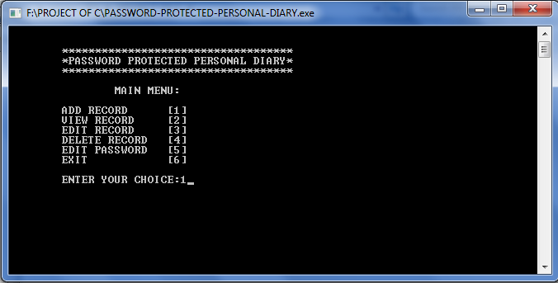

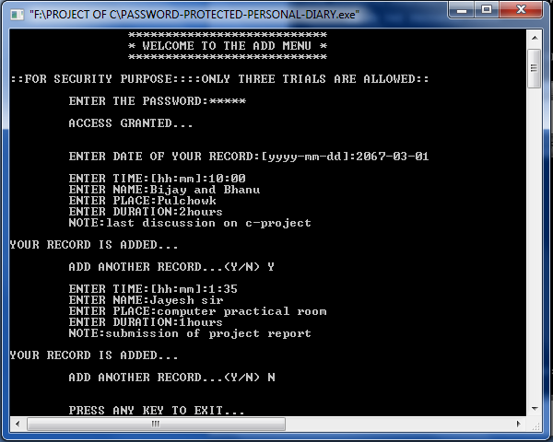

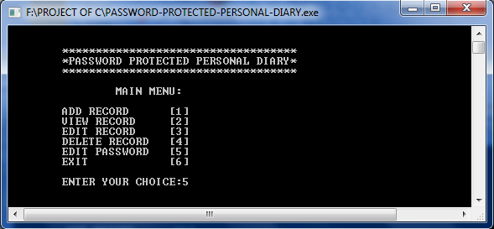

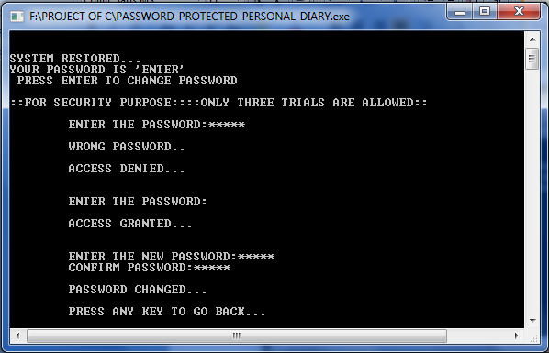

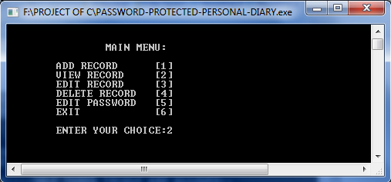

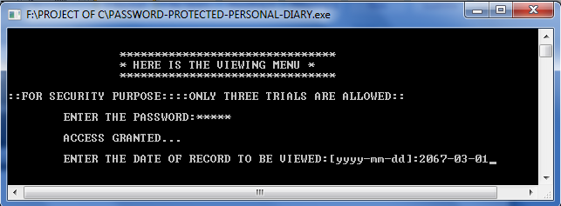

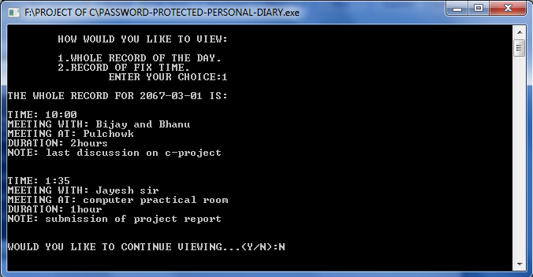

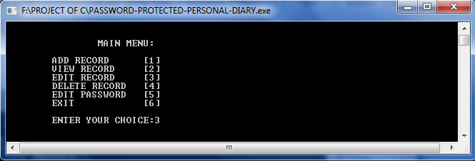

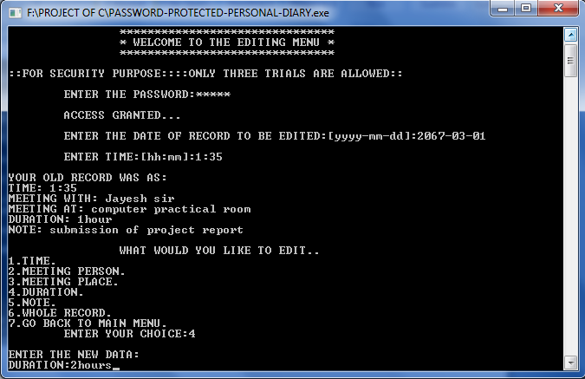

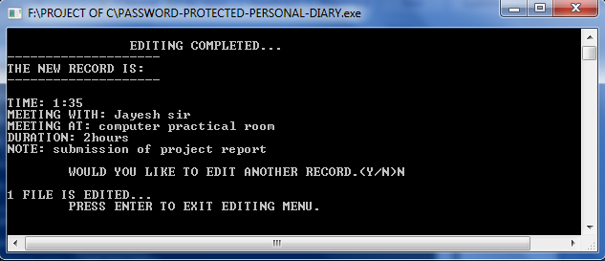

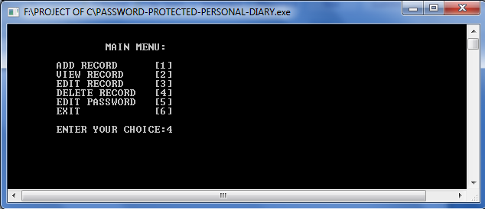

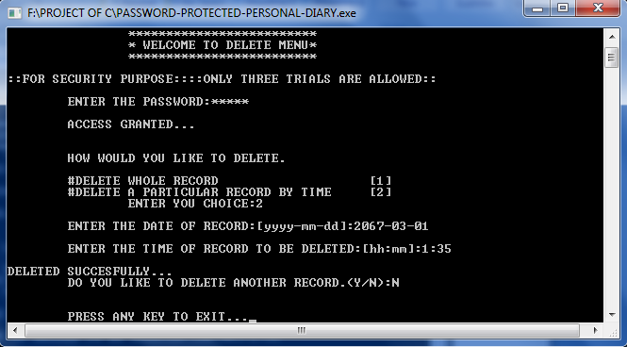

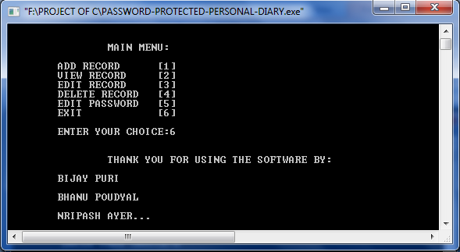

DISCUSSION:

During the project compilation, we face different problems on individual handling of tasks.
The first problem was on the edit menu. The file search was not working properly due to unarranged stored structure on file. This was solved by going step to step debugging. Another problem was with view menu. The specific viewing of a record by time was not working; it was also the same search problem. This was solved by group discussion. Another problem was with confirming password option; the function was not working properly. Password change function was a challenge to us. Searching different books and surfing internet at last kept us with solution. So solving through group effort was proved to be more efficient.

In this way, we completed our project successfully.

SUMMARY
Our main aim in this program is to prepare book record in library .The class modules and problems through done on the computers itself were much theoretical than practical because they were unable to teach us there application in our daily life.

The mini project on the other hand not only taught us practical use of program but also helped us in gaining skills like co-ordination, leadership, management of time, planning, foresights, etc. Above all it taught us that we could do something useful with c-programming. It gave taste of being a programmer which will very useful in our future.

Thus we can predict that we succeeded on our aim.The problems we faced make us more confident in C language.

